R. Reports Menu: 8. Export Permit Data

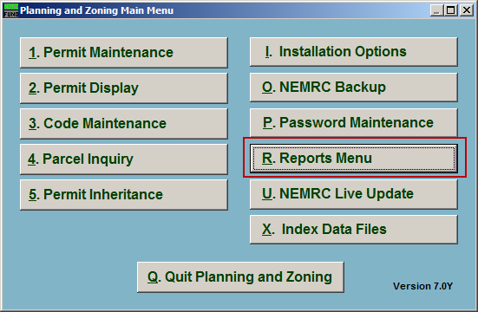
Click on “R. Reports Menu” from the Main Menu and the following window will appear:

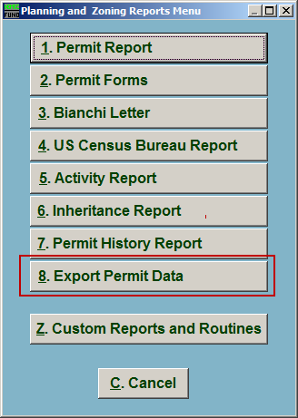
Click on “8. Export Permit Data” from the Reports Menu and the following window will appear:

Export Permit Data

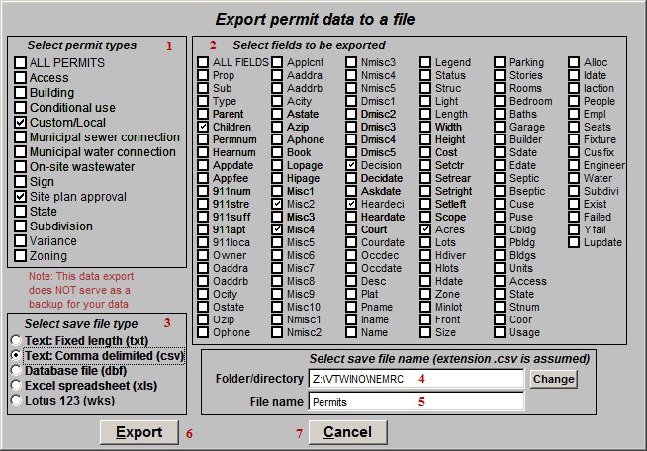
- Select permit types: Click to check the box next to the types of Permits to export.

- Select fields to be exported: Click to check the box next to the fields that will be exported.

- Select save file type: Select what file type to save this export as.

- Folder/directory: Enter the folder/directory to save this export in. Click the “Change” button to locate the folder using a windows folder lookup window.

- File name: Enter the file name to save this export under.

- Export: Click this button to export the Permit data as selected above.

- Cancel: Click “Cancel” to cancel and return to the Reports Menu.

